

CSC 1300 Syllabus, Fall 2024

Intro to Problem Solving & Computer Programming
  - Department of Computer Science, College of Engineering

Instructors & Graduate TA

April Crockett

Welcome to CSC 1300! I am a Senior Lecturer in the Department of Computer Science and have been teaching full-time in the department since 2018. I typically teach the introductory programming courses, data structures, algorithms, and the CS professionalism course that students take during their junior year. I will be the Purple Group instructor this semester.
Email: acrockett@tntech.edu
Office: Bruner Hall Room 330
Office Hours: Mondays 2:30 – 3:30pm, Tuesdays 12-1pm
I respond to messages within 24 hours Monday through Thursday and within 48 hours Friday through Sunday.

Brandon Vandergriff

Hi everyone! I'm Brandon Vandergriff. I am a Lecturer in the Department of Computer Science and have been teaching full-time in the department since Spring 2024. I graduated with both my bachelor's and master's degree in computer science from Tennessee Tech. I teach the introductory computer science classes. I will be the Gold Group instructor this semester.
Email: bvandergriff@tntech.edu
Office: Prescott Hall Room 318
Discord: brandonvandergriff
Office Hours: MW 12:00pm – 2:00pm, TR 11:00am – 1:00pm
I respond to messages within 24 hours Monday through Thursday and within 48 hours Friday through Sunday.

Kelsey Rainey


Howdy! I'm Kelsey Rainey, and I am the Graduate Teaching Assistant for CSC 1300 (and CSC 3410). I graduated with my bachelor’s degree from Tennessee Tech in Spring 2024 with a concentration in cybersecurity and am currently working on my master’s degree. I've been a teaching assistant for CSC 1300 for approximately 2 years now. I'll be here to answer any questions you have about lecture or labs!
Email: kkrainey42@tntech.edu
Discord: singingintherainey
Office Hours: TBD or email me

Supplemental Instruction (SI) Sessions
Supplemental Instructor: Baylee Stone
Email: bkstone42@tntech.edu
Extra Credit Opportunity:
Extra credit will be added to your FINAL CSC 1300 grade for attendance!
- Attend at least 8 sessions, +2 points added to your final grade
- Attend at least 6 sessions, +1.5 points added to your final grade
- Attend at least 4 sessions, +1 point added to your final grade

Course Logistic Information

All students during 1st Week of Class & Purple Group Location
Location: Bruner Hall (BRUN), Room 119
Days: Mondays, Wednesdays, & Fridays
Time: 9:00-9:50am

Gold Group Location (starting on September 4, 2024)
Location: Bruner Hall, Room 228
Days: Mondays, Wednesdays, & Fridays
Time: 9:00-9:50am

Lab Class:
- You are required to attend both lecture class and your lab class.
- The “CSC 1300 Fall 2024 Master Schedule.pdf” lists the weeks that you will attend lab and the first lab class is week of Monday, August 26th through Friday, August 30th.
- Lab assignments will be worked on during lab and will be 20% of your overall CSC 1300 grade.
- Students enrolled in CSC 1300 are distributed between ten different lab sections so that you have a smaller lab class where you can more easily get individual help and engage with other students.
- Students in your lab section may or may not be in your same lecture class.
- You will have two lab instructors, who will communicate with you via MS Teams.
- Below is a list of the lab sections, times, days, and locations. Refer to your schedule to know which lab section you are enrolled in.
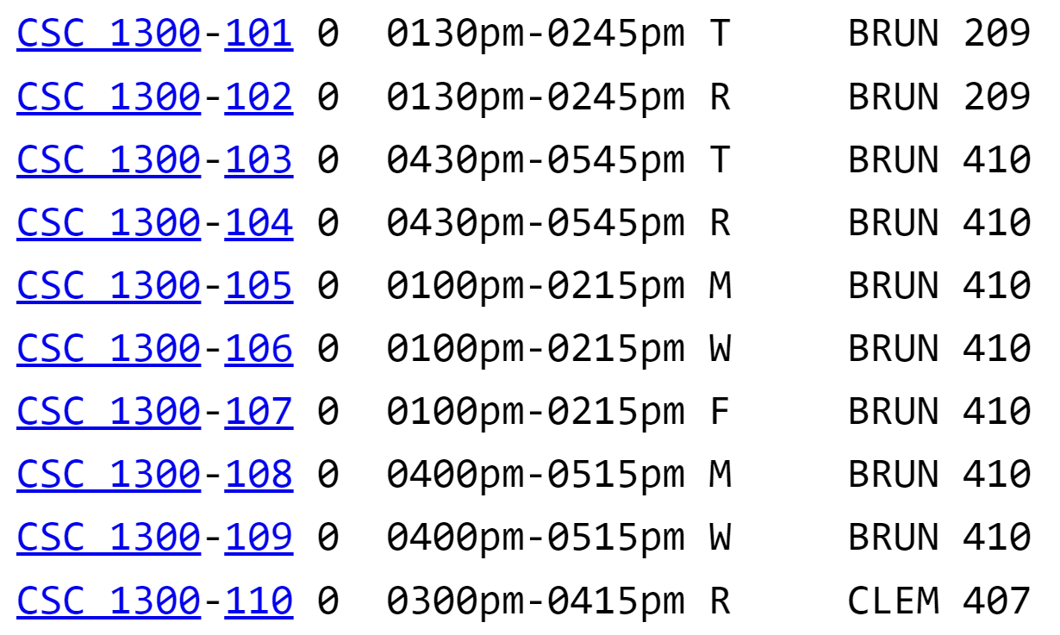

Course Overview

Course Description & Goal
This 4 credit-hour computer programming course introduces the student to the concepts of problem-solving and algorithm development in computing. The student will design and develop solutions to problems by writing procedural C++ computer programs. Students complete a series of weekly laboratory exercises for developing proficiency in problem solving and computer programming where design and testing are emphasized.

Requirements to Take the Course

Course Prerequisites/Corequisites
Students must meet one of the requirements below.
- Minimum Grade of ‘D’ in CSC 1200 Principles of Computing – may be taken concurrently.
- Minimum grade of ‘D’ in MATH 1845 Technical Calculus – may be taken concurrently.
- Minimum grade of ‘D’ in MATH 1910 Calculus I – may be taken concurrently.

Technology Requirements
- Laptop with internet access. Students should follow the College of Engineering recommended Computer Specifications https://www.tntech.edu/engineering/programs/resources/comp-specs.php
- Follow the “Getting your computer set up for CSC 1300” document to get the required software for the course, which includes a text editor and C++ compiler.

Time Requirements
- This course will require a time commitment of 4 hours of classroom & lab time, plus approximately 7-10 hours of “out-of-class” work for a total of 11-14 hours per week.

Major Teaching Methods
- Lectures with in-class activities
- Online interactive textbook with homework exercises
- Programming assignments
- Lab assignments

Required Materials & Instructional Platforms

Required Textbook – CSC 1300 ZyBook
There is no print textbook for this class. Instead, you will use an online textbook platform called ZyBook. You will have required reading and homework (worth 10% of your grade) that must be completed within this platform. You may either purchase access to the course ZyBook via the TTU bookstore, or alternately you can purchase directly through the ZyBook website after creating an account and entering in the code below. Either way works. (Don’t do both)
- Sign in or create an account at https://learn.zybooks.com using your Tennessee Tech email address.
  - Enter ZyBook code TNTECHCSC1300CrockettFall2024
  - Subscribe (subscription is $58 and lasts until January 3, 2025)
(Make sure to select your lecture section – either 001 or 002)

iLearn (TNTECH Learning Management System)
Tennessee Tech’s learning management system, iLearn https://elearn.tntech.edu, is where all announcements, course materials, and sample programs are for this course. All quizzes will be taken in iLearn and require the Respondus Lockdown Browser software available through iLearn. All grades are posted in iLearn. You will post and reply to discussions in iLearn, and you will also upload all work in iLearn. Turn on notifications in iLearn to ensure you do not miss any due dates.
- Set up your Notifications: https://www.tntech.edu/ilearn/pdf/ilearn-notifications.pdf
- Download the Brightspace Pulse App on your phone for quick access to course materials, schedules, and notifications.
  - Apple App Store: https://apps.apple.com/us/app/brightspace-pulse/id1001688546
  - Google Play: https://play.google.com/store/apps/details?id=com.d2l.brightspace.student.android

MS Teams
The instructors and lab instructors all use MS Teams to tell you about tutoring opportunities and to give you reminders about class & lab. Mrs. Crockett will be adding everyone to our CSC 1300 Fall 2024 Team. You will receive an email once you have been added to the team. If you haven’t been added to this team, please email Mrs. Crockett and let her know.

Etiquette Expectations

In this course, we hope to foster a climate of mutual respect where we learn and communicate together as a community where diverse perspectives are heard. Below is a list of expectations to ensure productive and effective discussions:
- It is expected that every student will participate actively, maturely, and respectfully in course discussions.
- Assume that others have the best intentions.
- Recognize and value the diverse backgrounds, experiences, abilities, and knowledge each person brings to the class.

Course Learning Objectives
- Students will be able to develop algorithms using problem-solving techniques.
- Students will be able to write introductory-level procedural programs in C++.
- Students will be able to evaluate, test, and debug computer programs.
- Students will be able to demonstrate acceptable computer programming practices.
- Students will demonstrate the ability to identify and implement algorithmic solutions that are representative of data parallelism.
- Students will be able to identify when a problem solution requires interaction with a remote service.
- Students will be able to develop and implement algorithmic solutions for interacting with a remote service.
- Students will be able to recognize when an algorithmic solution can benefit from the use of multiple threads that communicate via events or similar means of interaction.

Assessment

Grade Distribution
A: 90.0 to 100
B: 80.0 to 89.9
C: 70.0 to 79.9
D: 60.0 to 69.9
F: 59.9 and below

Grade Distribution by Assessment Type

Assessment Type | Percentage of Overall CSC 1300 Grade
Programming Assignments | 30%
Quizzes | 20%
Lab Assignments | 20%
ZyBook Homework | 10%
Final Exam | 10%
Participation | 10%

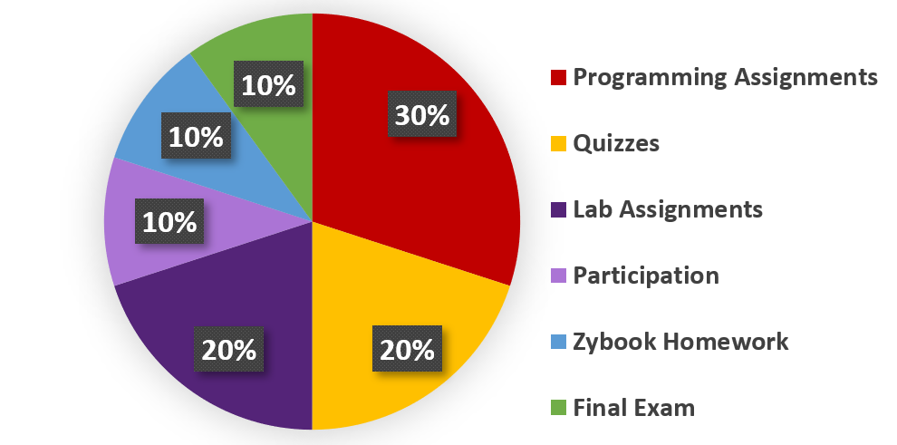

- Programming Assignments – there will be four major programs assigned in lecture class
- Quizzes – there will be eight 20-minute quizzes during class
- Final Exam – the final exam will be a programming assignment similar to a lab programming assignment that each student will complete within 2 hours during the final exam time.
- Lab Assignments –weekly assignments given to you in lab & work on them during lab
- ZyBook Homework – challenge & participation activities in the course ZyBook
- Participation – survey participation, programming aptitude quiz, participating in Kahoots during class, and watching assigned videos.

Course Policies

Grading Policy
- If you have an issue with any grade posted, you must contact me via email within 2 days of the grade being released.
- All grades will be posted to ilearn.
- Final grades are not rounded up. Example: If you earned an 89.9, then your final grade is a ‘B’.
All emails asking us to add points to your grade at the end of the semester will not be answered.
- ZyBook participation exercises will be graded within 1 week of completion.
- Programming assignments will be graded within 1.5-2 weeks of completion.

Late Assignment Policy
- Lecture programming assignments and lab assignments may be completed/submitted up to 2 days late at a penalty of 10% off per day late.
- After 2 days late, the assignment may not be submitted, and the grade will be a zero. Emailed submissions are not accepted.
- ZyBook Homework assignments may not be completed late.

Late Quiz Policy
- You must have a documented (doctor’s note), excused absence to make up a missed quiz.
- You must email Mrs. Crockett or Mr. Vandergriff within two days of missing a quiz to be eligible to make up the missed quiz.
- You will know which days there is a quiz because quiz dates are in the master schedule.

Email Policy
You will be expected to have your notifications set up in ilearn to receive an email when an announcement has been posted to your courses. You will be expected to check your Tennessee Tech email account at least once a day.

Student Academic Misconduct
Maintaining high standards of academic integrity in every class at Tennessee Tech is critical to the reputation of Tennessee Tech, its students, alumni, and the employers of Tennessee Tech graduates. The Student Academic Misconduct Policy describes the definitions of academic misconduct and policies and procedures for addressing Academic Misconduct at Tennessee Tech. For details, view the Tennessee Tech’s Policy 217 – Student Academic Misconduct (https://www.tntech.edu/policies/). It is the student’s responsibility to read, understand, and comply with this policy and ask for clarification if it is unclear about what is and is not allowed in all the requirements of this course.
The Department of Computer Science considers cheating to be a very serious offense and this conduct will result in a zero on the assignment as well as a submission for academic misconduct for all involved parties. Here is a list of activities that are considered cheating (Academic Misconduct) in CSC 1300 for individual assignments:
- Showing another CSC 1300 student more than a few lines of your code (both the person who shows code & the person receiving the code will be charged with Academic Misconduct). This includes emailing (or otherwise sending) your code to someone or looking at code that was emailed (or otherwise sent) to you.
- Using Artificial Intelligence (ChatGPT, Copilot, etc) to create or assist in creating your program. (See the Generative AI Policy below)
- Taking solutions off websites (such as Chegg) and forums and submitting them as your own work.
- Posting your solution to a public website (like Chegg or https://repl.it/).
- Paying someone to write your code.
You ARE encouraged to search for solutions to your problems online via resources discussed in class (cplusplus.com or stackoverflow) but do not copy/paste any code!

Generative AI Policy
In this course, Generative AI resources (like ChatGPT) are not permitted. Students are expected to do all coursework themselves, as an individual or collectively, as designated by the instructor per assignment. The use of a Generative AI Tool to complete coursework constitutes academic misconduct for this course.

Disability Accommodation
Students with a disability requiring accommodation should contact the Accessible Education Center (AEC). An Accommodation Request (AR) should be completed as soon as possible, preferably by the end of the first week of the course. The AEC is in the Roaden University Center on TTU campus, Room 112; email disability@tntech.edu and phone number (931) 372-6119.
For details, view the Tennessee Tech’s Policy 340 – Services for Students with Disabilities at Policy Central.

Let Others Get to Know You
One way that you can help build community between students and the instructor in this course is by letting others get to know you. Below are instructions on how you can change your name to your preferred name in iLearn and add your profile photo in iLearn and in your school email.

Change to Your Preferred Name in iLearn!
The Preferred Name Form is a form that you can fill out to update your preferred name information with Tennessee Tech systems (like TechConnect). This form is accessible on the Records, Registration, and Graduation Office’s forms site - https://www.tntech.edu/records/forms.php within the section “Student Records Forms” > “Preferred Name Change”.

Add Your Profile Photo to ILearn
- Click on your name in the top-right corner of ilearn once you are logged in.
- Click “Profile”
- Click “Change Picture”

Add Your Profile Photo to Microsoft 365
One helpful thing you can do to let your instructors or potential future employers get to know you is to add a profile picture to your TTU email in outlook. It is easy. Here are directions on how to do it: https://support.office.com/en-us/article/add-your-profile-photo-to-office-365-2eaf93fd-b3f1-43b9-9cdc-bdcd548435b7

Additional Campus Resources

Technical Help
If you are experiencing technical problems, visit the myTech IT Helpdesk for assistance.
If you are having trouble with one of the instructional technologies (i.e. Zoom, Teams, Qualtrics, iLearn Respondus, or any technology listed here) visit the Center for Innovation in Teaching and Learning (CITL) website or call 931-372-3675 for assistance.
For accessibility information and statements for our instructional technologies, visit the CITL's Learner Success Resource page.

Tutoring
The university provides free online and in-person tutoring to all Tennessee Tech students – including in Computer Science classes. Tutoring is available for any class or subject, as well as writing, test prep, study skills, and resume support. Appointments are scheduled, so contact the Learning Center website for more information.

Health and Wellness

Counseling Center
The Counseling Center offers brief, short-term, solution-focused therapeutic interventions for Tennessee Tech University students. The staff of the Counseling Center is available to assist students with their personal and social concerns in hopes of helping them achieve satisfying educational and life experiences. To learn more or schedule an appointment, visit the Counseling Center website.

Health Services
Health Services offers high-quality, affordable care that is accessible and promotes the health and wellness of our Tennessee Tech community. Visit the Health Services website to learn more.

Syllabus is Tentative
The syllabus and schedule is subject to change.

